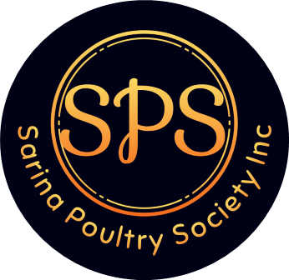

President: Darryl Keir Phone: 0439 710 943
Secretary: Lisa Keir Phone: 0438 249 907
Treasurer: Karen Perry Phone: 0427 166 824

APPLICATION FOR MEMBERSHIP 2026
for March 2026 – February 2027
First Name:………………………………………………………Surname:……………………………………………………….
Address: ……………………………………………………………………………………………………………………………….
Suburb/Town……………………………………………………State……………………..Postcode………………………….
Telephone No: …………………………………………………………………………………………………………………….
Email:………………………………………………………………………………………………………………………….………….
Child under 16 years Membership: $ 2.50
Single Membership: $ 5.00
Family Membership: $10.00
I give authorization for Sarina Poultry Society to give out my email/phone number Yes……………No………..

I/We hereby enclosed the amount of $..........................................being membership for the
Sarina Poultry Society Inc
Signed:………………………………………………….............

Direct Debit:
Sarina Poultry Society
Bendigo Bank
BSB 633-000
Account Number: 155418452

